ONTLAMETSE MOGAPI

PROG6212 POE PART 1

ST10244738

**Documentation**

**1.1 Design Choices:**

* **Framework:** For this project, I decided to use Windows Presentation Foundation (WPF) because of its versatility in creating contemporary, responsive user interfaces. Rich features for UI design and concern separation (XAML for UI and C# for logic) are provided by WPF. I went with a blue colour design, which I think it would cool for the user.
* **Structure:**
  + **MainWindow:** The main pane serves as the primary interface via which instructors submit their personal information and make claims. The form is divided into two primary sections: Claim Details and Personal Details.
  + **Classes:**
    - Lecturer: Holds personal information such as name, surname, and employee number.
    - Claim: Stores claim-specific information, including module, hours worked, and hourly rate.

**1.2 Database Structure:**

Although this is a prototype with a strong emphasis on user interface, this system will eventually make use of a relational database (like SQL Server). Lecturers and Claims could be the two primary tables in the framework.

* **Lecturers Table**:
  + LecturerID (Primary Key)
  + FirstName
  + LastName
  + EmployeeNo
  + ContactDetails
* **Claims Table**:
  + ClaimID (Primary Key)
  + LecturerID (Foreign Key referencing Lecturers)
  + Module
  + Programme
  + NumberOfHours
  + HourlyRate

**1.3 GUI Layout:**

The layout is designed to be simple and user-friendly, divided into two sections:

* **Personal Details**: Where lecturers enter their name, surname, employee number, and contact details.
* **Claim Details**: Where lecturers specify the module, program, hours worked, and hourly rate.
* **Buttons**:
  + "Add Another Module" to dynamically add more modules to the claim.
  + "Submit Claim" to finalize and submit the claim (currently, a message box is shown).
  + “Upload supporting documents” for the lecture to upload the documents for the work they completed.

**1.4 Assumptions and Constraints:**

* **Assumptions**:
  + Each lecturer can claim multiple modules within a single submission.
  + The lecturer manually enters the hourly rates and total hours.
* **Constraints**:
* The system does not yet have a database connection; it is merely a prototype.
* This prototype does not contain user management or authentication for simplicity's sake.

**UML Class Diagram for Database**

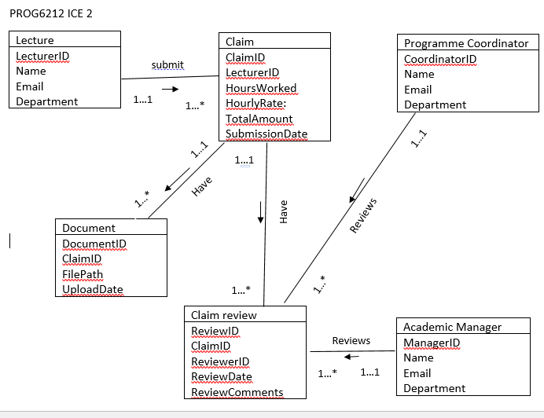

**Project Plan**

**Phases and Tasks**

| **Phase** | **Tasks** | **Dependencies** | **Duration** |
| --- | --- | --- | --- |
| **Phase 1: Planning** | - Identify project scope and requirements | None | 1 day |
|  | - Gather UI specifications (fields, buttons, layout) |  |  |
| **Phase 2: UI Design** | - Create the WPF project in Visual Studio | Completion of Planning | 4 days |
|  | - Design the Lecturer Claim Form in XAML |  |  |
|  | - Organize the UI with grids, labels, textboxes, and buttons |  |  |
| **Phase 3: Logic Setup** | - Implement basic event handlers (e.g., Add Another Module, Submit Claim) | Completion of UI Design | 6 days |
| **Phase 4: Testing** | - Test the form interactions, ensure layout is correct | Completion of Logic Setup | 1 day |
|  | - Debug any UI-related issues |  |  |
| **Phase 5: Documentation** | - Write detailed documentation on design choices and architecture | Completion of Testing | 2 day |
| **Phase 6: Submission** | - Prepare project for submission | Completion of Documentation | 1 day |

**Timeline Overview:**

* **Total Duration**: Approximately 15 days (2 week).
* Each phase has dependencies based on the completion of the previous phase.

**Milestones:**

1. **Day 1**: Finalize requirements and design specifications.
2. **Day 3**: UI layout completed in WPF.
3. **Day 5**: Basic logic implemented for buttons.
4. **Day 6**: Form testing and debugging complete.
5. **Day 7**: Final submission preparation.

**Screenshot**

